Acer 5K Gaming Display Script

Reference Image | Super
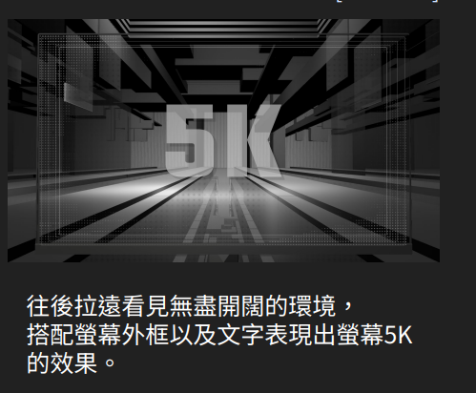 | Ultra-Crisp Clarity  5K | 5120 x 2880¹
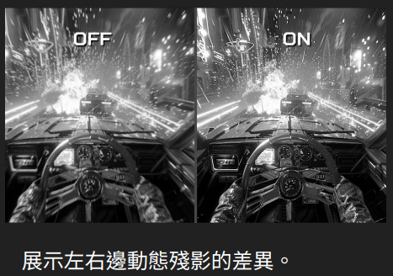 | VRB Pro Motion Clarity  0.5ms Response Time¹
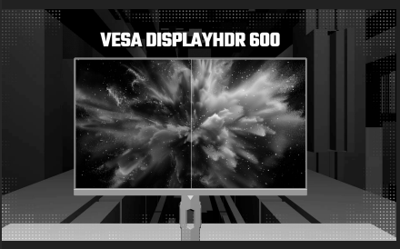 | VESA DisplayHDR™ 600¹
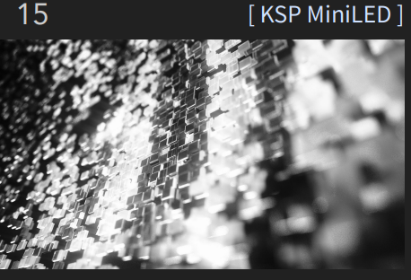 | MiniLED Display Option
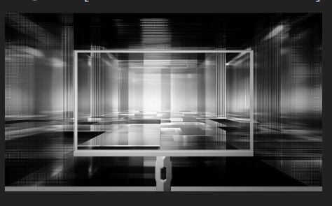 | Dual Color Gamut  DCI-P3 | Adobe RGB¹
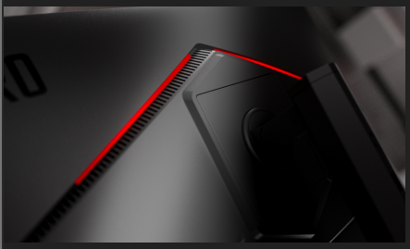 | Ambient RGB Lighting¹
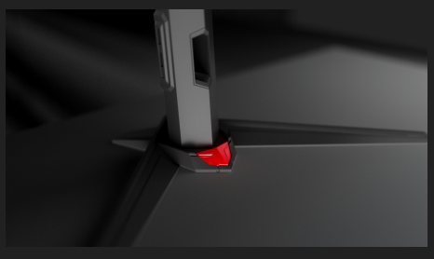 | Motion Sensor Lighting¹
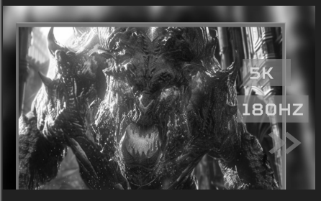 | 5K 180Hz Refresh Rate¹
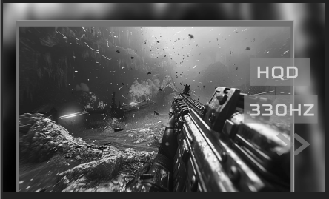 | QHD 330Hz via DFR¹
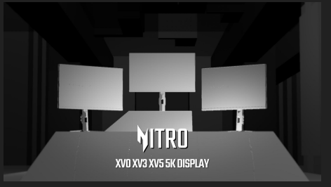 | Acer 5K Gaming Displays

Disclaimers:
1. Specifications may vary depending on model and/or region. All models subject to availability.
2. Refresh rate, response time, resolution, color gamut, MiniLED, RGB lighting, motion sensor lighting, and Dynamic Frequency and Resolution support may vary by model and configuration.
3. 5K 180Hz and QHD 330Hz via Dynamic Frequency and Resolution require compatible hardware, supported settings, and applicable connection bandwidth.
4. Response time specifications may vary depending on test conditions, display settings, and usage.

